|  |  |
| --- | --- |
| cid:image004.png@01CF7F10.A4275880 | LOGO4 |
| Best Buy Canada Mobile | |
| |  | | --- | | **Related Items Feature Document** |   **Document Version: 1.2**  **Revision Date: April 1, 2015** | |
| **Prepared By: Amy Byers** | |
|  | |

**Table of Contents**

*1.* *Feature Overview* 3

1.1 Feature Description 3

1.2 Assumptions 3

1.3 Parameters and System Settings 3

1.4 Interfaces 3

*2.* *USE CASE: Related Items – Selection Lists* 4

2.1 Feature Flow 4

2.2 Precondition 4

2.3 Main Flow 4

2.4 Alternate Flows 5

2.5 Post Condition 5

2.6 Special Requirements 5

*3.* *USE CASE: Related Items – Mandatory* 6

3.1 Feature Flow 6

3.2 Precondition 6

3.3 Main Flow 6

3.4 Alternate Flows 6

3.5 Post Condition 6

3.6 Special Requirements 6

*4.* *USE CASE: Related Items – Suggested Sell* 7

4.1 Feature Flow 7

4.2 Precondition 7

4.3 Main Flow 7

4.4 Alternate Flows 7

4.5 Post Condition 7

4.6 Special Requirements 7

*5.* *Supplemental Specifications* 8

5.1 Electronic Journal 8

5.2 Line Item Delete 8

5.3 POSLog 8

5.4 Printed Receipts 8

5.5 Sale 8

5.6 Suspend 8

*6.* *Screen Layouts* 9

6.1 Related Item Selection List 9

*7.* *Business Sign Off* 10

*8.* *Revision History* 10

*9.* *Appendix A: Glossary* 10

# *Feature Overview*

## Feature Description

The Point of Sale system supports creating relationships of items that are suggested sell, mandatory. An item may contain all of the different types of relationships.

Mandatory relationships are where selling an item triggers the automatic adding of an item(s).

Mandatory-Optional Selection relationships are where the system displays a list of related items and the system requires an item to be selected prior to continuing selling the trigger item. Optional Selection relationships are where the system displays a list of related items and the system does not require an item to be selected to continue selling the trigger item. Once a selection is made, the system does not allow the selection to be changed. An example includes selling a cell phone which triggers the selection of a cell phone plan and then that cell phone plan displays a list of promotion packages.

Suggested Sell relationships are a list of items have been identified that further entice customers to add additional products to their purchase. Suggested selling practices include having the Point of Sale application passively display suggested selling items, which includes warranty items that are available for a product item.

## Assumptions

1. All text displayed by the system is configurable by brand to support multi-language.  Text is defined from an external source or defined within the system.
2. All Manager Overrides are bypassed.

## Parameters and System Settings

|  |  |  |
| --- | --- | --- |
| **Parameter Mnemonic** | **Description** | **Valid Values** |
| Signature Required | Determines if a function or an acceptance of Terms and Conditions requires a signature. The parameter also defines if the signature for a feature can be consolidated. | Current Scope:   * Warranty Item – PSP * Warranty Item – PRP * Item Tax Exempt * Tran Tax Exempt * Warranty Item – Monthly * Subscription Item * General Item Attribute for Signature Capture with Terms |
| Suggested Sell Transaction Types | Determines the transaction types where Suggested Sell is available | * Sale |
| Employee Eligible Relationships | Determines if a relationship is eligible for an employee transaction. The system checks employee eligible flag on a relationship before presenting it to the user. | * On * Off |
| No E Waste Sale Flag | Determines if an E Waste mandatory relationship type is processed for transaction IBH | * On * Off |

## Interfaces

|  |  |
| --- | --- |
| **Interface** | **Description** |
| None | Item lookup service? |

# *USE CASE: Related Items – Selection Lists*

## Feature Flow



## Precondition

* An item is added to the basket.

## Main Flow

1. The system determines if the trigger item has any selection list related items (either optional or mandatory).
2. If the system does not contain any selection list related items, the use case ends and the system returns to the calling use case without any related items to add to the transaction.
3. The system displays the selection list for the item.
4. The operator makes a selection and accepts the entry.
5. The system evaluates the selection.
6. If a mandatory selection was not made, the system displays a message, the operator acknowledges the message and the system returns to the step in the Main Flow where the system displays the selection list(s).
7. If an optional selection was not made, the No Optional Selection alternate flow is executed.
8. The system determines if the relationship contains another level based upon the selected item.
9. If another level exists in the current relationship, the system restarts the Main Flow.
10. The system saves the selected items.
11. The use case ends and the system returns to the calling use case with related items to add to the transaction.

## Alternate Flows

### No Optional Selection

1. The system displays a message confirming that no selection was made.
2. If the operator selects to continue without a selection, the system returns to the step in the Main Flow where the system saves the selected items.
3. If the operator selects to return to make a selection, the system returns to the step in the Main Flow where the system displays the selection list(s).

## Post Condition

* A required related item is added to the transaction.

## Special Requirements

1. A relationship contains a parent with one-to-many children. If a child item is sold on its own, it does not trigger the relationship.
2. Upon completing the Related Item process; focus remains on the item that triggered the Related Item process until the operator enters a new item to the virtual basket or manually moves the focus.
3. An item added through any of the relationship processes will follow through the normal item selling process which includes going through the related item process to pickup additional relationships.
4. An item may contain more than one type of relationship associated with it.
5. The selected item may contain its own relationship requirements before that item is added to the transaction.
6. The items selected in the list are added to the transaction after the trigger item has completed its sale processing.
7. The relationships between items are not displayed on the Item Entry screen.
8. Each level in the relationship may contain the following three types of relationships – Mandatory, Mandatory-Optional Selection List, Optional Selection List.
9. Related Item are required based upon transaction type.
10. Related Items are defined by the customer type: (**Note**: Employee functionality is a future enhancement)

* 11 – All customers are eligible for the relationship prompt
* 01 – Only employees are eligible for the relationship prompt
* 10 – All customer except employees are not eligible
* 00 – No one is eligible for the relationship prompt

1. The order to display the customer prompts is defined in the data.

### Special Offline Requirements

TBD

### Data Input/Output

|  |  |  |
| --- | --- | --- |
| **Data Element** | **Description** | **Destination** |
| Relationship Link | The relationship link between the parent and children. | * E-Journal * POSLog * Receipt |

# *USE CASE: Related Items – Mandatory*

## Feature Flow



## Precondition

* An item is added to the basket.

## Main Flow

1. The system determines if the trigger item has any mandatory related items.
2. If there are no required related items, the use case ends and the system returns to the calling use case without any related items to add to the transaction.
3. If the mandatory relationship type is E-Waste and No E Waste flag is enabled for the transaction IBH, the use case ends and the system returns to the calling use case without any related items to add to the transaction.
4. The use case ends and the system returns to the calling use case with related items to add to the transaction.

## Alternate Flows

None

## Post Condition

* A required related item is added to the transaction.

## Special Requirements

1. A relationship contains a parent with one-to-many children. If a child item is sold on its own, it does not trigger the relationship.
2. Upon completing the Related Item process; focus remains on the item that triggered the Related Item process until the operator enters a new item to the virtual basket or manually moves the focus.
3. An item added through any of the relationship processes will follow through the normal item selling process which includes going through the related item process to pickup additional relationships.
4. An item may contain more than one type of relationship associated with it.
5. Mandatory relationships (automatic adding an item to the transaction) are fulfilled after the trigger item has completed its sale processing.
6. The relationships between items are not displayed on the Item Entry screen.
7. Each level in the relationship may contain the following three types of relationships – Mandatory, Mandatory-Optional Selection List, Optional Selection List.
8. Related Item are required based upon transaction type.
9. Related Items are defined by the customer type: (**Note**: Employee functionality is a future enhancement)

* 11 – All customers are eligible for the relationship prompt
* 01 – Only employees are eligible for the relationship prompt
* 10 – All customer except employees are not eligible
* 00 – No one is eligible for the relationship prompt

### Special Offline Requirements

TBD

### Data Input/Output

|  |  |  |
| --- | --- | --- |
| **Data Element** | **Description** | **Destination** |
| Relationship Link | The relationship link between the parent and children. | * E-Journal * POSLog * Receipt |

# *USE CASE: Related Items – Suggested Sell*

## Feature Flow



## Precondition

* Suggested Sell functionality is enabled.

## Main Flow

1. The system determines if the transaction type is eligible for suggested sell.
2. If the transaction type is not eligible, the use case ends and the system returns to the calling use case without a suggested sell list.
3. The system determines if the trigger item has any suggested sell related items.
4. If there are no suggested sell related items, the use case ends and the system returns to the calling use case without a suggested sell list.
5. The use case ends and the system returns to the calling use case with a suggested sell list to be displayed when the trigger item is selected in Item Entry.

## Alternate Flows

None

## Post Condition

* A required related item is added to the transaction.

## Special Requirements

1. A relationship contains a parent with one-to-many children. If a child item is sold on its own, it does not trigger the relationship.
2. The related items suggest sell list consists of warranty items that are associated to the product item. The checks that the current price of the item falls within the warranty item’s price band. For example if Item A is associated Warranty X, Y and Z and the warranty price band for X and Y is that the product item price needs to be between $300-$700 and warranty price band for Z is that the product item price needs to be between $500-$900, then if the product A is sold with the price of $400 then only warranty items X and Y will be displayed.
3. An item may contain more than one type of relationship associated with it.
4. The relationships between items are not displayed on the Item Entry screen.
5. Items with a quantity greater than 1 are not eligible for suggested sell items.

### Special Offline Requirements

TBD

### Data Input/Output

|  |  |  |
| --- | --- | --- |
| **Data Element** | **Description** | **Destination** |
| Relationship Link | The relationship link between the parent and children. | * E-Journal * POSLog * Receipt |

# *Supplemental Specifications*

## Electronic Journal

Electronic journal mockups for this feature are documented in the Electronic Journal document.

## Line Item Delete

The Line Item Delete Use case is updated to include the additional child deletion rules.

## POSLog

POSLog mockups for this feature are documented in the POSLog document.

## Printed Receipts

Printed receipt mockups, where applicable, are documented in the Receipt Generation document.

## Sale

The Sale Use Case is updated to display suggested sell list.

## Suspend

The Suspend Use Case is updated to reflect that the selections made during the related item process are saved and is part of the resume transaction.

# *Screen Layouts*

## Mandatory-Optional Related Item Selection List

This screen is displayed when an item that is added to the transaction contains a mandatory-optional selection lists.

### Mockup

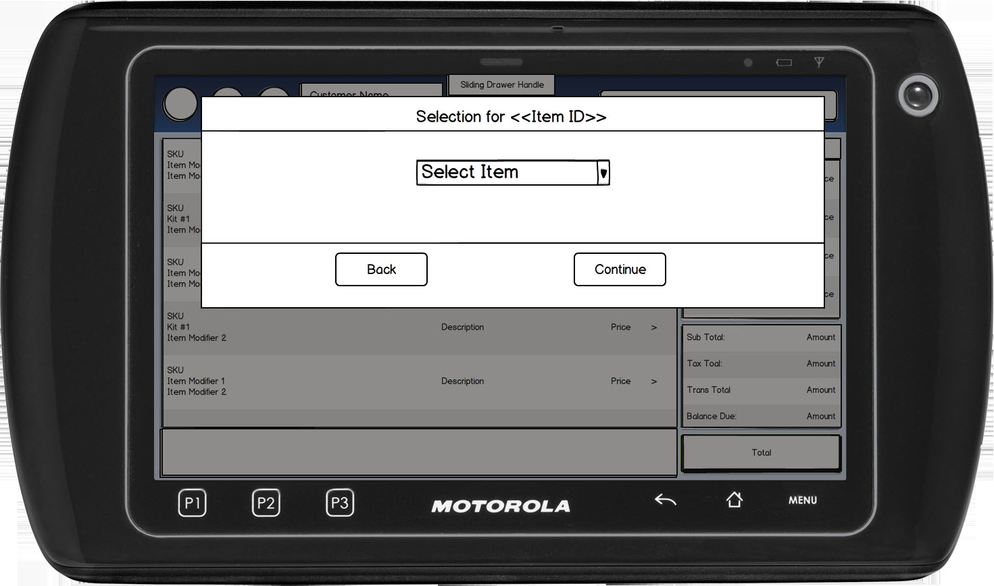

Figure 1: Related Item Selection List

### Instruction Text

|  |
| --- |
| **Instructions** |
| Select Item |

### Navigation/Menu Key

|  |  |  |  |
| --- | --- | --- | --- |
| **Label** | **State** | **Next Screen** | **Notes** |
| Back | Enabled | Sale use case | None |
| Continue | See Notes | * No additional prompts required: Sale use case * Additional prompts required: Related Item Selection List | The Continue button is not enabled until a selection is made. |

### Data/Input Field

|  |  |  |  |  |  |  |
| --- | --- | --- | --- | --- | --- | --- |
| **Label** | **Editable** | **Req’d?** | **Data Type** | **Min**  **Length** | **Max**  **Length** | **Notes** |
| Select Item | Yes | See Notes | See Notes | See Notes | See Notes | The type of relationship determines if the selection is mandatory or optional.  No default selection is made. |

### Reason Code

|  |  |  |
| --- | --- | --- |
| **Reason Code** | **Valid Values** | **Default Value** |
| None |  |  |

### Mandatory Selection Not Made

|  |  |
| --- | --- |
| **Description** | The message is displayed when a selection was not made on a mandatory selection list. Upon acknowledging the message, the system returns to Related Item Selection List screen. |
| **Message** | An item must be selected. |
| **Key prompt** | OK |
| **Notes** | Configurable message |

### Optional Selection Not Made

|  |  |
| --- | --- |
| **Description** | The message is displayed when a selection was not made on an optional selection list. The system prompts the user if the customer would like to continue without making the selection.   * If the operator selects No, the system returns to the Related Item Selection List screen. * If the operator selects Yes, the system continues with the next step in the Main Flow. |
| **Message** | An Item has not been selected. Is this correct? |
| **Key prompt** | * Yes * No |
| **Notes** | Configurable message |

# *Business Sign Off*

|  |  |  |
| --- | --- | --- |
| **Name** | **Organization** | **Date** |
|  |  |  |

# *Revision History*

|  |  |  |  |
| --- | --- | --- | --- |
| **Reviser** | **Revision** | **Date** | **Version** |
| Amy Lackas | Initial document created. This version includes the following changes: Employee Transaction. | 07/16/2013 | 1.0 |
| Amy Byers | Added quantity items are not eligible for suggested sell | 3/20/2015 | 1.1 |
| Amy Byers | Added No E Waste Sale IBH Flag feature | 4/1/2015 | 1.2 |

# *Appendix A: Glossary*

|  |  |
| --- | --- |
| **Term** | **Definition** |
| Trigger Item | The top level item in a relationship. This item initiates the relationship process. |
| Child Item | The items in a relationship that |
| IBH | International Business Hierarchy |